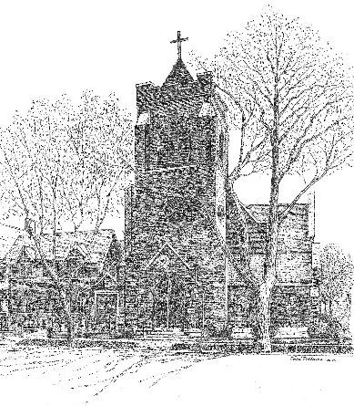
St. Timothy’s Episcopal Church, Wilson, NC
The Second Sunday of Advent
Year A
December 7, 2025
Celebrant and Preacher: Rev. Adele Hatfield
Organist: Kara Zaharin
Greeter: Bill & Carla Stakes (8:00), Mary Lynn Barnes (10:30); Ushers: David Taylor, Brent Walston (10:30)
Lay Reader: Jim Davis (8:00), Cameron Homes (10:30)
Eucharistic Ministers: Jim Davis (8:00); Eliza Stepenson (L), Jackson Byrum(R), (10:30)
Altar Guild: Carol Putney, Bill & Carla Stakes, Dorothy Jeffrey, Thomas Farmer
Counters: Melba Martin, Scott Thomson
Acolytes: Naomi Byrum,
Let us remember that the nave is a place of prayer and worship. Please enter reverently, keeping conversation to a whisper and to a minimum as your brothers and sisters in Christ may be trying to pray in preparation for the Holy Eucharist. We hope you will stay and visit with each other after the service. Appropriate devotional prayers for Sundays, before and after worship, and before and after receiving Holy Communion can be found on Pages 833-835 of the Book of Common Prayer. In addition, there are appropriate Psalms that can be prayed in preparation for worship, such as Psalms 84, 85, 86, 116, and 130. The Psalter can be found from Pages 585-808 in the Book of Common Prayer.

Holy Eucharist Rite I 8:00 Am
The 10:30 AM Rite II service begins on Page 2 of this bulletin.
Welcome & Announcements

The people stand as they are able as the Sacred Ministers process in silence.

Opening Acclamation BCP p. 323
Collect for Purity
Summary of the Law BCP p. 324
Kyrie
Gloria
Collect of the Day BCP p. 325
Readings & Psalm See Pages 3-4 in this bulletin.
Sermon
The Nicene Creed BCP p. 327
Prayers of the People BCP p. 389
During the silence to follow each paragraph, the congregation adds prayers aloud or in their hearts.
Confession & Absolution BCP p. 330
The Peace BCP p. 332
Offertory BCP p. 333
The Great Thanksgiving: Eucharistic Prayer I
Lord's Prayer BCP p. 336

The Fraction Anthems BCP p. 337
The Prayer of Humble Access

We believe in the Real Presence of Christ in the Blessed Sacrament, the consecrated bread and wine. Communion in the Episcopal Church is open to all baptized Christians and they are invited at this time to the altar rail to receive Christ’s Body and Blood. If you require a gluten-free wafer, please inform the Priest and one will be provided for you. Please let an usher know if you need Communion brought to your seat for any reason. If you wish to receive a blessing, please come forward and cross your arms over your chest to signify that to the Priest.

Post-Communion Prayer BCP p. 339
Blessing
Dismissal
Holy Eucharist Rite II 10:30 Am
Prelude
Lighting of the Advent Candle and Children’s Choir
Welcome & Announcements

The Word of God

Processional Hymn Hark! A thrilling voice is sounding The Hymnal 1982 #59
Opening Acclamation BCP 355
The people standing, the Celebrant says
Celebrant | +Blessed be God: Father, Son, and Holy Spirit
People | And blessed be his kingdom, now and for ever. Amen.
The Celebrant prays the Collect for Purity BCP 355
Almighty God, to you all hearts are open, all desires known, and from you no secrets are hid: Cleanse the thoughts of our hearts by the inspiration of your Holy Spirit, that we may perfectly love you, and worthily magnify your holy Name; through Christ our Lord. Amen.

The Trisagion is sung three times The Hymnal 1982 S-102
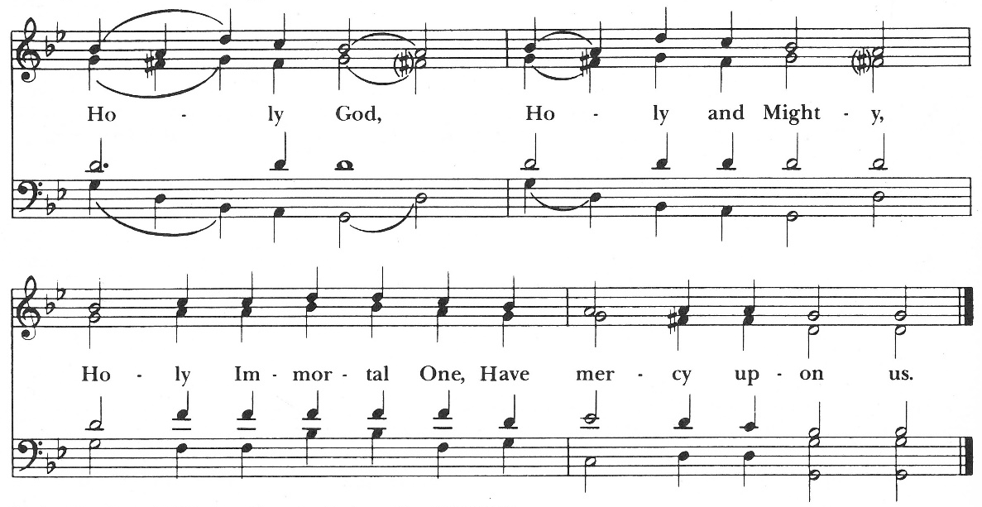

After the Trisagion, the Celebrant faces the People and says,
 | The Lord be with you.
People | And also with you.
Celebrant | Let us pray.

The Celebrant says the Collect of the Day BCP 211
Merciful God, who sent your messengers the prophets to preach repentance and prepare the way for our salvation: Give us grace to heed their warnings and forsake our sins, that we may greet with joy the coming of Jesus Christ our Redeemer; who lives and reigns with you and the Holy Spirit, one God, now and for ever. Amen.

The children are dismissed to children’s church.

The First Lesson Isaiah 11:1-10
A reading from Isaiah.
A shoot shall come out from the stump of Jesse,
and a branch shall grow out of his roots.
The spirit of the Lord shall rest on him,
the spirit of wisdom and understanding,
the spirit of counsel and might,
the spirit of knowledge and the fear of the Lord.
His delight shall be in the fear of the Lord.
He shall not judge by what his eyes see,
or decide by what his ears hear;
but with righteousness he shall judge the poor,
and decide with equity for the meek of the earth;
he shall strike the earth with the rod of his mouth,
and with the breath of his lips he shall kill the wicked.
Righteousness shall be the belt around his waist,
and faithfulness the belt around his loins.
The wolf shall live with the lamb,
the leopard shall lie down with the kid,
the calf and the lion and the fatling together,
and a little child shall lead them.
The cow and the bear shall graze,
their young shall lie down together; and the lion shall eat straw like the
ox.
The nursing child shall play over the hole of the asp,
and the weaned child shall put its hand on the adder's den.
They will not hurt or destroy
on all my holy mountain;
for the earth will be full of the knowledge of the Lord
as the waters cover the sea.
On that day the root of Jesse shall stand as a signal to the peoples; the nations shall inquire of him, and his dwelling shall be glorious.

Reader The Word of the Lord.
People Thanks be to God.

The Response: Psalm 72:1-7, 18-19 Deus, judicium BCP 685

8:00 – The Psalm is read responsively by whole verse.
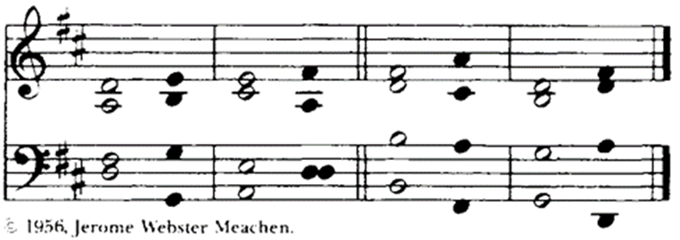
10:30 – The Psalm is chanted in unison.

¹ Give the King your justice, O God, *
and your righteousness to the King's Son;
² That he may rule your people righteously *
and the poor with justice;
³ That the mountains may bring prosperity to the people, *
and the little hills bring righteousness.
⁴ He shall defend the needy among the people; *
he shall rescue the poor and crush the oppressor.
⁵ He shall live as long as the sun and moon endure, *
from one generation to another.
⁶ He shall come down like rain upon the mown field, *
like showers that water the earth.
⁷ In his time shall the righteous flourish; *
there shall be abundance of peace till the moon shall be no more.
¹⁸ Blessed be the Lord God, the God of Israel, *
who alone does wondrous deeds!
¹⁹ And blessed be his glorious Name for ever! *
and may all the earth be filled with his glory.
Amen. Amen.

The Second Lesson Romans 15:4-13

A reading from Romans.
Whatever was written in former days was written for our instruction, so that by steadfastness and by the encouragement of the scriptures we might have hope. May the God of steadfastness and encouragement grant you to live in harmony with one another, in accordance with Christ Jesus, so that together you may with one voice glorify the God and Father of our Lord Jesus Christ.
Welcome one another, therefore, just as Christ has welcomed you, for the glory of God. For I tell you that Christ has become a servant of the circumcised on behalf of the truth of God in order that he might confirm the promises given to the patriarchs, and in order that the Gentiles might glorify God for his mercy. As it is written,
"Therefore I will confess you among the Gentiles,
and sing praises to your name";
and again he says,
"Rejoice, O Gentiles, with his people";
and again,
"Praise the Lord, all you Gentiles,
and let all the peoples praise him";
and again Isaiah says,
"The root of Jesse shall come,
the one who rises to rule the Gentiles;
in him the Gentiles shall hope."
May the God of hope fill you with all joy and peace in believing, so that you may abound in hope by the power of the Holy Spirit.
Reader The Word of the Lord.
People Thanks be to God.
* Sequence Hymn O come, o come Emmanuel The Hymnal 1982 #56
Then, all standing, the Deacon or a Priest reads the Gospel, first saying
 | The Holy Gospel of our Lord Jesus Christ according to Matthew.
+++ For some it is customary at this time to use our thumbs to trace three small crosses upon our foreheads, lips, and chests to signify keeping the Gospel in our minds, on our lips, and in our hearts.
People | Glory to you, Lord Christ.

* The Gospel Matthew 3:1-12
In those days John the Baptist appeared in the wilderness of Judea, proclaiming, “Repent, for the kingdom of heaven has come near.” This is the one of whom the prophet Isaiah spoke when he said,
“The voice of one crying out in the wilderness:
‘Prepare the way of the Lord,
make his paths straight.’”
Now John wore clothing of camel’s hair with a leather belt around his waist, and his food was locusts and wild honey. Then the people of Jerusalem and all Judea were going out to him, and all the region along the Jordan, and they were baptized by him in the river Jordan, confessing their sins.
But when he saw many Pharisees and Sadducees coming for baptism, he said to them, “You brood of vipers! Who warned you to flee from the wrath to come? Bear fruit worthy of repentance. Do not presume to say to yourselves, ‘We have Abraham as our ancestor’; for I tell you, God is able from these stones to raise up children to Abraham. Even now the ax is lying at the root of the trees; every tree therefore that does not bear good fruit is cut down and thrown into the fire.
“I baptize you with water for repentance, but one who is more powerful than I is coming after me; I am not worthy to carry his sandals. He will baptize you with the Holy Spirit and fire. His winnowing fork is in his hand, and he will clear his threshing floor and will gather his wheat into the granary; but the chaff he will burn with unquenchable fire.”
 | The Gospel of the Lord.
People | Praise to you, Lord Christ.
The Sermon The Rev. Adele Hatfield

Nicene Creed BCP 358
Please stand as you are able

We believe in one God,
the Father, the Almighty,
maker of heaven and earth,
of all that is, seen and unseen.
We believe in one Lord, Jesus Christ,
the only Son of God,
eternally begotten of the Father,
God from God, Light from Light,
true God from true God,
begotten, not made,
of one Being with the Father.
Through him all things were made.
For us and for our salvation
he came down from heaven:
by the power of the Holy Spirit
he became incarnate from the Virgin Mary,
and was made man.
For our sake he was crucified under Pontius Pilate;
he suffered death and was buried.
On the third day he rose again
in accordance with the Scriptures;
he ascended into heaven
and is seated at the right hand of the Father.
He will come again in glory to judge the living and the dead,
and his kingdom will have no end.
We believe in the Holy Spirit, the Lord, the giver of life,
who proceeds from the Father and the Son.
With the Father and the Son he is worshiped and glorified.
He has spoken through the Prophets.
We believe in one holy catholic and apostolic Church.
We acknowledge one baptism for the forgiveness of sins.
We look for the + resurrection of the dead,
and the life of the world to come. Amen.

* Prayers of the People
The prophet John the Baptist preached a repentance which would bear fruit in the lives of those who heard him. In penitence and faith, let us offer to God our prayer for all people, saying: In the name of Christ, hear our prayer.

We pray for the church throughout the world, especially our sisters and brothers and for all those ordained to particular ministries for the building up for the body of Christ, that in our diverse vocations we may serve to the glory of God. In the name of Christ,
Hear our prayer.

We pray for this nation and for all the nations of the world remembering especially those who are victims of political or social injustice. We pray for those whom we have elected to public office and for political leaders everywhere, that they may administer the tasks of government with courage and equity. In the name of Christ,
Hear our prayer.

We pray for the sick, the elderly, and those who live alone, especially, Sharon Wethington, Cameron Shearin, Craig Jackson, Carter Grine, Robyn Camden, Jim Godfrey, Ralph Worrell, Lamont Futrell, Phyllis Connor, Christy Mutchler, John Bohne, Dawson Noble, Pat Holloman, Grace McLean, George Weaver, Allen, Becky, Jean Long, Lisa Summerlin, Shane Brown, Janet Beaver, Jane Schoenberg, Mary Ann Ruffin Catherine Walston, Jill and Roger and Jerry Lanier. Peace for the people of Israel, Palestine, Ukraine, Russia, Ethiopia, and all refugees fleeing nations mired in military conflict; the people of Syria, Turkey, Canada, and all peoples recovering from natural disasters. For those who are depressed or lonely… for the men and women serving in our armed forces at home or abroad. We pray for those who are overworked and for those who cannot find work. Send upon them the power of the Holy Spirit, that they may abound in hope. In the name of Christ,
Hear our prayer.

We pray for this community, for our neighbors and friends, for those with whom we study and work. Guide and strengthen us all in our common life that we may know the gifts or your grace and love. In the name of Christ,
Hear our prayer.

We pray for God’s blessing upon our parishioners who are celebrating birthdays this week: Zhuri Harris, Katy King. In the name of Christ,
Hear our prayer.

Almighty God, you know the needs of your Church in every place: Look graciously upon us, the people of St. Timothy’s, and grant us the guidance of your Holy Spirit as we seek a new Rector for this parish. Give us discernment, wisdom, and confidence in your timing. We pray for the life of our parish, that we may be a community that welcomes all and nurtures worship, prayer, study and service to the glory of your name. In the name of Christ,
Hear our prayer.

We offer these prayers to you, our God, in penitence for what is past and in faith that your work in us will bear fruit as we seek to do your will, for you alone are the Holy One. May our lives give honor to you, through Christ our Lord. Amen.

The Celebrant concludes with a suitable Collect to which the People respond, Amen.
O Lord our God, accept the fervent prayers of your people; in the multitude of your mercies, look with compassion upon us and all who turn to you for help; for you are gracious, O lover of souls, and to you we give glory, Father, Son, and Holy Spirit, now and for ever. Amen.
Confession of Sin
The Celebrant says the following sentence of Scripture and bids the faithful to Confession.
Jesus said, “The first commandment is this: Hear, O Israel: The Lord our God is the only Lord. Love the Lord your God with all your heart, with all your soul, with all your mind, and with all your strength. The second is this: Love your neighbor as yourself. There is no other commandment greater than these. Mark 12:29-31

Let us confess our sins against God and our neighbor.
Silence is kept.
Minister and People
Most merciful God,
we confess that we have sinned against you
in thought, word, and deed,
by what we have done,
and by what we have left undone.
We have not loved you with our whole heart;
we have not loved our neighbors as ourselves.
We are truly sorry and we humbly repent.
For the sake of your Son Jesus Christ,
have mercy on us and forgive us;
that we may delight in your will,
and walk in your ways,
to the glory of your Name. Amen.

The Bishop, when present, or the Priest, stands and says
Almighty God have mercy on you, + forgive you all your sins through our Lord Jesus Christ, strengthen you in all goodness, and by the power of the Holy Spirit keep you in eternal life. Amen.
.* The Peace BCP 360
All stand. The Celebrant says to the people
 | The peace of the Lord be always with you.
People | And also with you.
Then the Ministers and People may greet one another in the name of the Lord.
The Holy Communion
Offertory Sentence
The Offertory begins with the following words. The people are seated while the altar is prepared.
Walk in love, as Christ loved us and gave himself for us, an offering and sacrifice to God. Ephesians 5:2
Chancel Choir Anthem Jesus, Joy of Man’s Desiring
* The Doxology The Hymnal 1982 #380 v.3
Praise God from whom all blessings flow
Praise Him all creatures here below
Praise Him above ye heavenly hosts
Praise Father, Son and Holy Ghost. Amen

Celebrant All things come of Thee, O Lord;
People And of Thine own have we given Thee.

* Eucharistic Prayer B BCP 361
The people remain standing. The Celebrant, whether bishop or priest, faces them and sings or says

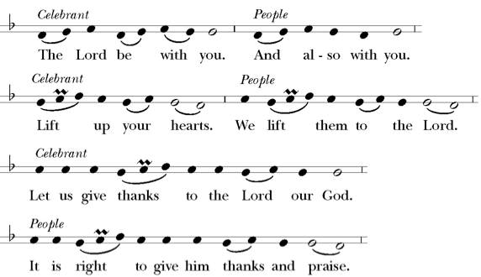

Then, facing the Holy Table, the Celebrant proceeds
It is right, and a good and joyful thing, always and everywhere to give thanks to you, Father Almighty, Creator of heaven and earth. Because you sent your beloved Son to redeem us from sin and death, and to make us heirs in him of everlasting life; that when he shall come again in power and great triumph to judge the world, we may without shame or fear rejoice to behold his appearing. Therefore we praise you, joining our voices with Angels and Archangels and with all the company of heaven, who for ever sing this hymn to proclaim the glory of your Name:
The Sanctus and Benedictus

Holy, holy, holy Lord The Hymnal 1982 S-130
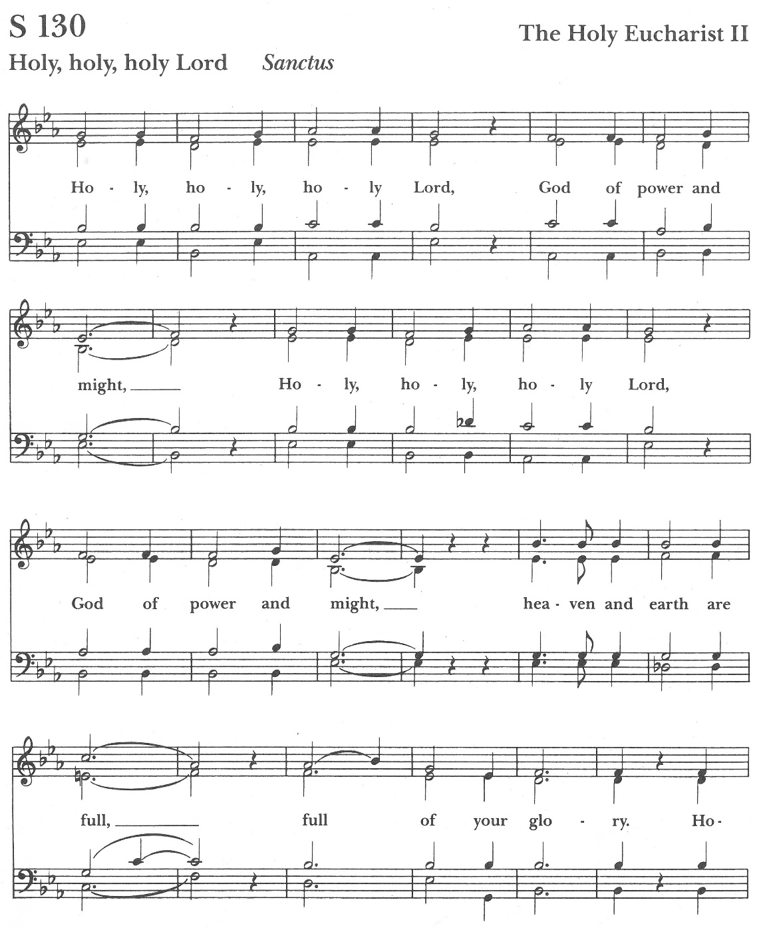

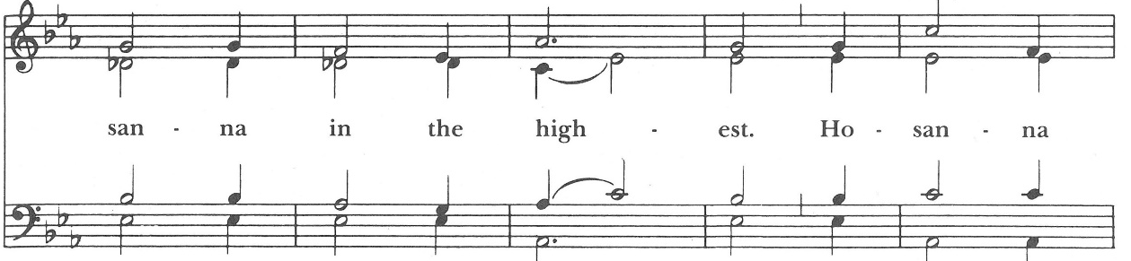

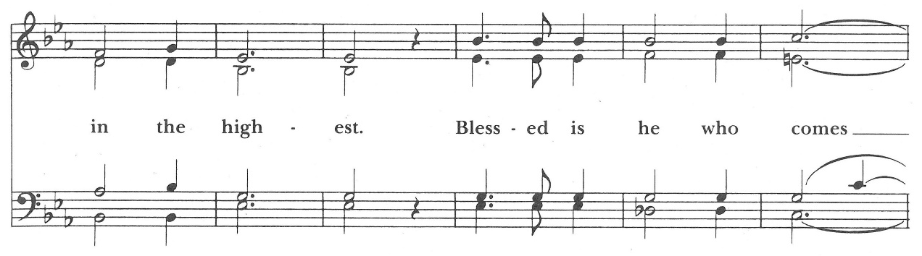

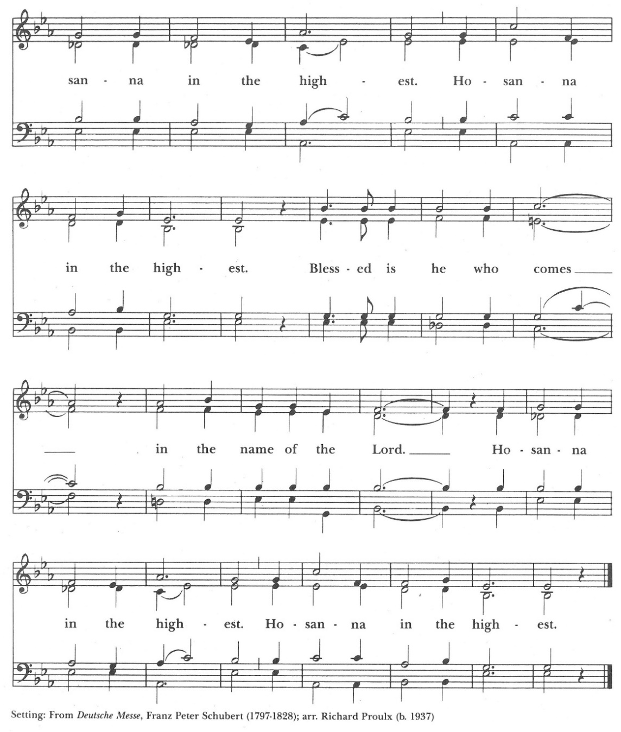

The people stand or kneel.
Then the Celebrant continues
We give thanks to you, O God, for the goodness and love which you have made known to us in creation; in the calling of Israel to be your people; in your Word spoken through the prophets; and above all in the Word made flesh, Jesus, your Son. For in these last days you sent him to be incarnate from the Virgin Mary, to be the Savior and Redeemer of the world. In him, you have delivered us from evil, and made us worthy to stand before you. In him, you have brought us out of error into truth, out of sin into righteousness, out of death into life.

On the night before he died for us, our Lord Jesus Christ took bread; and when he had given thanks to you, he broke it, and gave it to his disciples, and said, "Take, eat: This is my Body, which is given for you. Do this for the remembrance of me." +

After supper he took the cup of wine; and when he had given thanks, he gave it to them, and said, "Drink this, all of you: This is my Blood of the new Covenant, which is shed for you and for many for the forgiveness of sins. Whenever you drink it, do this for the remembrance of me." +

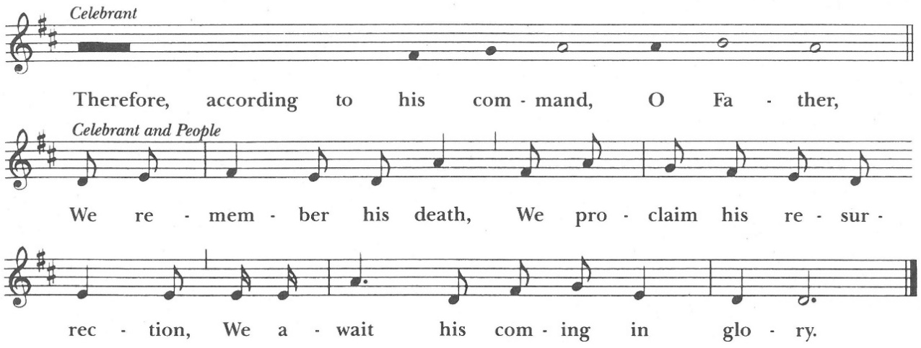

The Celebrant continues
And we offer our sacrifice of praise and thanksgiving to you, O Lord of all; presenting to you, from your creation, this bread and this wine. We pray you, gracious God, to send your Holy Spirit upon these gifts that they may be the Sacrament of the Body of Christ and his Blood of the new Covenant. + Unite us to your Son in his sacrifice, that we may be acceptable through him, being sanctified by the Holy Spirit.

In the fullness of time, put all things in subjection under your Christ, and bring us to that heavenly country where, with the Ever-Blessed Virgin Mary, Mother of God, St. Timothy, our patron, and all your saints, we may enter the everlasting heritage of your sons and daughters; through Jesus Christ our Lord, the firstborn of all creation, the head of the Church, and the author of our salvation. By him, and with him, and in him, in the unity of the Holy Spirit all honor and glory is yours, Almighty Father, now and for ever. +
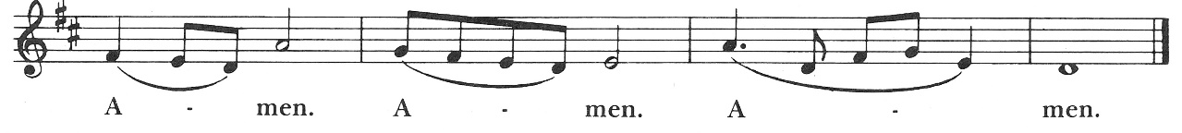

And now, as our Savior
Christ has taught us,
we are bold to say,

The Lord’s Prayer BCP 364
Our Father, who art in heaven,
hallowed be thy Name,
thy kingdom come,
thy will be done,
on earth as it is in heaven.
Give us this day our daily bread.
And forgive us our trespasses,
as we forgive those
who trespass against us.
And lead us not into temptation,
but deliver us from evil.
For thine is the kingdom,
and the power, and the glory,
for ever and ever. Amen.

Fraction BCP 364
The Celebrant breaks the consecrated Bread+. A period of silence is kept. Then may be sung or said
Alleluia. Christ our Passover is sacrificed for us;
People Therefore let us keep the feast. Alleluia

The Agnus Dei
Lamb of God |  | The Hymnal 1982 S-164
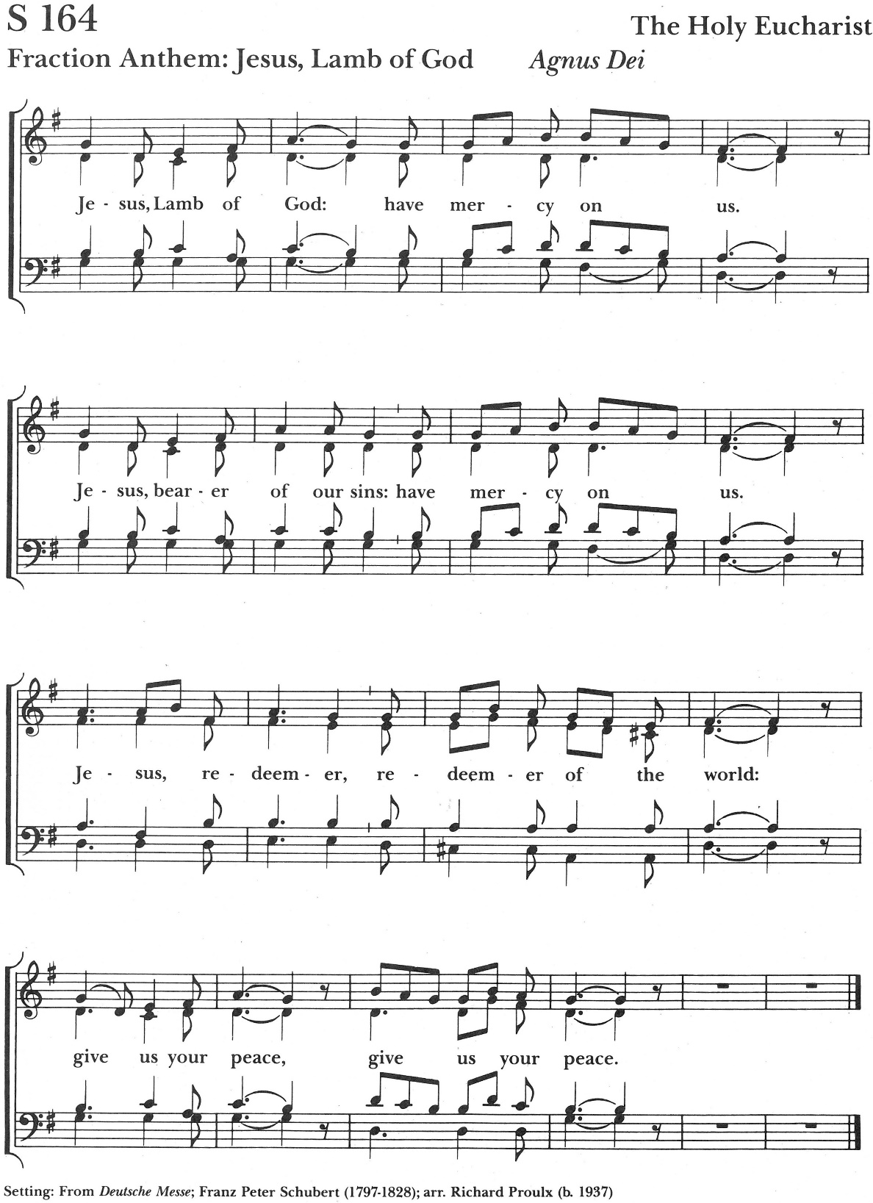

Facing the people, the Celebrant says the following Invitation
The Gifts of God for the People of God. Take them in remembrance that Christ died for you, and feed on him in your hearts by faith, with thanksgiving.

Hymns at Communion What is this crying at Jordan The Hymnal 1982 #69
Lo, how a rose e’er blooming The Hymnal 1982 #81
O day of piece that dimly shines The Hymnal 1982 #597
We believe in the Real Presence of Christ in the Blessed Sacrament, the consecrated bread and wine. Communion in the Episcopal Church is open to all baptized
Christians and they are invited at this time to the altar rail to receive Christ’s Body and Blood. If you require a gluten-free wafer, please inform the Priest and one will be provided for you. Please let an usher know if you need Communion brought to your seat for any reason. If you wish to receive a blessing, please come forward and cross
your arms over your chest to signify that to the Priest. Prayers are offered in the Baptistry Chapel at the back of the church.

Post Communion Prayer BCP 366
After Communion, the Celebrant says
Let us pray.

Celebrant and People
Almighty and everliving God,
we thank you for feeding us with the spiritual food
of the most precious Body and Blood
of your Son our Savior Jesus Christ;
and for assuring us in these holy mysteries
that we are living members of the Body of your Son,
and heirs of your eternal kingdom.
And now, Father, send us out
to do the work you have given us to do,
to love and serve you
as faithful witnesses of Christ our Lord.
To him, to you, and to the Holy Spirit,
be honor and glory, now and for ever. Amen.

Lay Eucharistic Visitors are sent forth by all, saying: We send you forth bearing these holy gifts, that those to whom you go may share with us one
bread and one cup, the communion of Christ’s body and blood.

Blessing
The priest blesses the people, saying
The peace of God, which passes all understanding, keep your hearts and minds in the knowledge and love of God, and of his Son Jesus Christ our Lord; and the blessing of God Almighty, the +Father, the Son, and the Holy Spirit, be among you, and remain with you always. Amen.

* Recessional Hymn Comfort, comfort ye my people The Hymnal1982#67

* Dismissal
Celebrant Go in peace, glorifying the LORD by your life.
People Thanks be to God.
Postlude



The Altar flowers are given to the glory

In loving memory of

Anna Barnette Byrum

By

Her Family


Announcements

12/102025 -Noon HE and Healing service in the chapel.

12/10/2025-Choir practice at 4:30pm.

12/10/2025-Dinner, Bible study, Children’s Choir, Whirlikids, and EYC.
We have openings for altar flowers on December the 21st and the 28th are available. Please call the office or Ruth Schoenberg at 252-293-0300 if interested in filling one of the spots.
Please remember to complete your 2026 pledge before the end of the year.
🌺🎄 Exciting news! This year we're switching things up and ordering Anthuriums instead of Poinsettias. These beautiful red houseplants can be kept all year long, avoiding the wasteful tradition of throwing them away after Christmas. Each Anthurium is $38, the order forms are in your bulletin, or you can drop by the church office and pick one up. Let's bring some fresh vibes into the holiday season with these lovely plants! 🌺🎄Order forms are due by December 8th.
The 2026 pledge cards have been mailed out. Please prayerfully consider what your pledge will be and turn in your cards by December 14th.
St. Tim’s Lunch Bunch will meet today following the 10:30am service. They are headed to Western Sizzlin.
Our monthly Parish Breakfast is next Sunday, December 14th. The annual meeting will be held during this time.
The Wesley Shelter Angel gifts need to be turned into the office by December 12. Include your unwrapped gifts in a big bag with the Angel tag attached.

Additional "angels" will be added to the tree for blankets that are needed for the First Christian Church Christmas luncheon. After lunch, the participants are each given blankets. In past years, they have run out of blankets. Any help is very appreciated.
There is still time to nominate someone for the Vestry. If you have a person you would like to nominate, please use the form located in your bulletin and make sure, the form is turned into the church office by Monday, December 8th.

The Vestry

Class of 2025: Ann Barnes, Melba Martin, Bob Putney, Melissa Rees
Class of 2026: Lee Stephenson, Parker Garrett, Linda Connor, Sammy Gilmore
Class of 2027: Brandon McLean, Ray Harris, Kathryn Harrison, Scott Thompson

Welcome to St. Timothy's Episcopal Church! We are a welcoming, inclusive, and affirming church guided by scripture, tradition, and reason. We invite you to experience a relationship with Jesus, empowered by the Holy Spirit, by participating in the liturgy, engaging with the scriptures, and abiding in this Christian community of faith. In baptism, we covenant with God and each other striving for justice and peace, seeking Christ in all persons, loving our neighbors as ourselves, and respecting the dignity of every human being. We believe God loves you, just as you are, and so do we! So, whoever you are and wherever you are in your spiritual journey, you will be welcomed, loved, and affirmed at St. Timothy's. Everybody needs a place. We invite you to make this place your church home.



The second Sunday of Advent candle symbolizes peace and faith, often called the "Peace Candle" or "Bethlehem Candle". It represents the peace that Jesus brings and commemorates the journey of Mary and Joseph to Bethlehem, signifying preparation for the coming of Christ. The second candle is typically purple, representing royalty, repentance, and preparation.

