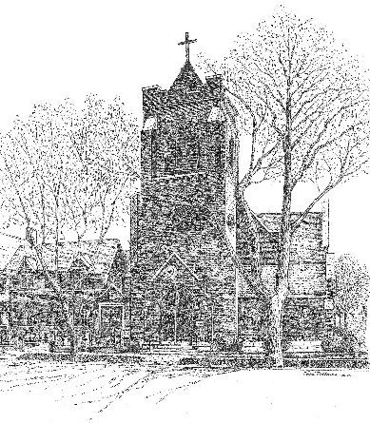
St. Timothy’s Episcopal Church, Wilson, NC
All Saints Day
Year C
November 2, 2025
Celebrant and Preacher: Rev. George Greer
Organist: Kara Zaharan
Greeter: Kathie Davis (8:00), Catherine Walston (10:30); Ushers: Bryant Jenkins, Henry Long (10:30)
Lay Reader: Jim Davis (8:00), Brandon McLean (10:30)
Eucharistic Ministers: Jim Davis (8:00); Eliza Stephenson (L), Hugh Hussey (R), (10:30)
Altar Guild: Elisabeth Skinner, Margaret Jenkins, Lisa Robbins, Melissa Rees
Counters: Brandon McLean, Parker Garrett
Acolytes: Frances Ross, Dallas Ross
Let us remember that the nave is a place of prayer and worship. Please enter reverently, keeping conversation to a whisper and to a minimum as your brothers and sisters in Christ may be trying to pray in preparation for the Holy Eucharist. We hope you will stay and visit with each other after the service. Appropriate devotional prayers for Sundays, before and after worship, and before and after receiving Holy Communion can be found on Pages 833-835 of the Book of Common Prayer. In addition, there are appropriate Psalms that can be prayed in preparation for worship, such as Psalms 84, 85, 86, 116, and 130. The Psalter can be found from Pages 585-808 in the Book of Common Prayer.

Holy Eucharist Rite I 8:00 Am
The 10:30 AM Rite II service begins on Page 2 of this bulletin.
Welcome & Announcements

The people stand as they are able as the Sacred Ministers process in silence.

Opening Acclamation BCP p. 323
Collect for Purity
Summary of the Law BCP p. 324
Kyrie
Gloria
Collect of the Day BCP p. 325
Readings & Psalm See Pages 2-5 in this bulletin.
Sermon
The Nicene Creed BCP p. 327
Prayers of the People BCP p. 328
During the silence to follow each paragraph, the congregation adds prayers aloud or in their hearts.
Confession & Absolution BCP p. 330
The Peace BCP p. 332
Offertory BCP p. 333
The Great Thanksgiving: Eucharistic Prayer I
Lord's Prayer BCP p. 336

The Fraction Anthems BCP p. 337
The Prayer of Humble Access

We believe in the Real Presence of Christ in the Blessed Sacrament, the consecrated bread and wine. Communion in the Episcopal Church is open to all baptized Christians and they are invited at this time to the altar rail to receive Christ’s Body and Blood. If you require a gluten-free wafer, please inform the Priest and one will be provided for you. Please let an usher know if you need Communion brought to your seat for any reason. If you wish to receive a blessing, please come forward and cross your arms over your chest to signify that to the Priest.

Post-Communion Prayer BCP p. 339
Blessing
Dismissal
Holy Eucharist Rite II 10:30 Am
Prelude
Welcome & Announcements

The Word of God

Processional Hymn For all the saints, who from their labors rest The Hymnal 1982 #287
Opening Acclamation BCP 355
The people standing, the Celebrant says
Celebrant | +Blessed be God: Father, Son, and Holy Spirit
People | And blessed be his kingdom, now and for ever. Amen.
The Celebrant prays the Collect for Purity BCP 355
Almighty God, to you all hearts are open, all desires known, and from you no secrets are hid: Cleanse the thoughts of our hearts by the inspiration of your Holy Spirit, that we may perfectly love you, and worthily magnify your holy Name; through Christ our Lord. Amen.

The Gloria Glory to God The Hymnal 1982 S-280

After the Gloria, the Celebrant faces the People and says,
 | The Lord be with you.
People | And also with you.
Celebrant | Let us pray.

The Celebrant says the Collect of the Day BCP 245
Almighty God, you have knit together your elect in one communion and fellowship in the mystical body of your Son Christ our Lord: Give us grace so to follow your blessed saints in all virtuous and godly living, that we may come to those ineffable joys that you have prepared for those who truly love you; through Jesus Christ our Lord, who with you and the Holy Spirit lives and reigns, one God, in glory everlasting. Amen.

The First Lesson Daniel 7:1-3,15-18
A reading from Daniel.

In the first year of King Belshazzar of Babylon, Daniel had a dream and visions of his head as he lay in bed. Then he wrote down the dream: I, Daniel, saw in my vision by night the four winds of heaven stirring up the great sea, and four great beasts came up out of the sea, different from one another.
As for me, Daniel, my spirit was troubled within me, and the visions of my head terrified me. I approached one of the attendants to ask him the truth concerning all this. So he said that he would disclose to me the interpretation of the matter: "As for these four great beasts, four kings shall arise out of the earth. But the holy ones of the Most High shall receive the kingdom and possess the kingdom for ever—for ever and ever."

Reader The Word of the Lord.
People Thanks be to God.

The Response: Psalm 149 Cantate Domino BCP 807

8:00 – The Psalm is read responsively by whole verse.
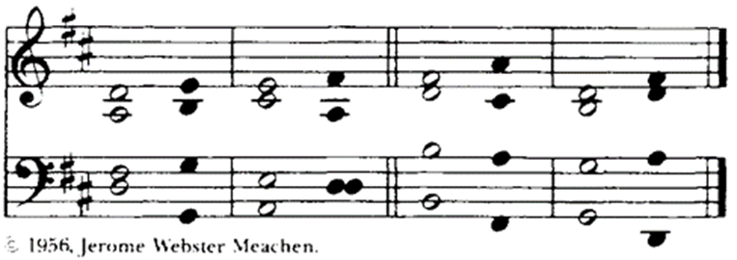
10:30 – The Psalm is chanted in unison.

¹ Hallelujah!
Sing to the Lord a new song; *
sing his praise in the congregation of the faithful.
² Let Israel rejoice in his Maker; *
let the children of Zion be joyful in their King.
³ Let them praise his Name in the dance; *
let them sing praise to him with timbrel and harp.
⁴ For the Lord takes pleasure in his people *
and adorns the poor with victory.
⁵ Let the faithful rejoice in triumph; *
let them be joyful on their beds.
⁶ Let the praises of God be in their throat *
and a two-edged sword in their hand;
⁷ To wreak vengeance on the nations *
and punishment on the peoples;
8 To bind their kings in chains *
and their nobles with links of iron;
⁹ To inflict on them the judgment decreed; *
this is glory for all his faithful people.
Hallelujah!

The Second Lesson Ephesians 1:11-23

A reading from Ephesians.
In Christ we have also obtained an inheritance, having been destined according to the purpose of him who accomplishes all things according to his counsel and will, so that we, who were the first to set our hope on Christ, might live for the praise of his glory. In him you also, when you had heard the word of truth, the gospel of your salvation, and had believed in him, were marked with the seal of the promised Holy Spirit; this is the pledge of our inheritance toward redemption as God's own people, to the praise of his glory.
I have heard of your faith in the Lord Jesus and your love toward all the saints, and for this reason I do not cease to give thanks for you as I remember you in my prayers. I pray that the God of our Lord Jesus Christ, the Father of glory, may give you a spirit of wisdom and revelation as you come to know him, so that, with the eyes of your heart enlightened, you may know what is the hope to which he has called you, what are the riches of his glorious inheritance among the saints, and what is the immeasurable greatness of his power for us who believe, according to the working of his great power. God put this power to work in Christ when he raised him from the dead and seated him at his right hand in the heavenly places, far above all rule and authority and power and dominion, and above every name that is named, not only in this age but also in the age to come. And he has put all things under his feet and has made him the head over all things for the church, which is his body, the fullness of him who fills all in all.
Reader The Word of the Lord.
People Thanks be to God.
* Sequence Hymn Blessed Jesus, at thy word The Hymnal 1982 #601
Then, all standing, the Deacon or a Priest reads the Gospel, first saying
 | The Holy Gospel of our Lord Jesus Christ according to Luke.
+++ For some it is customary at this time to use our thumbs to trace three small crosses upon our foreheads, lips, and chests to signify keeping the Gospel in our minds, on our lips, and in our hearts.
People | Glory to you, Lord Christ.

* The Gospel Luke 6:20-31

Jesus looked up at his disciples and said:

“Blessed are you who are poor,
for yours is the kingdom of God.

“Blessed are you who are hungry now,
for you will be filled.

“Blessed are you who weep now,
for you will laugh.

“Blessed are you when people hate you, and when they exclude you, revile you, and defame you on account of the Son of Man. Rejoice in that day and leap for joy, for surely your reward is great in heaven; for that is what their ancestors did to the prophets."

"But woe to you who are rich,
for you have received your consolation.

"Woe to you who are full now,
for you will be hungry.

"Woe to you who are laughing now,
for you will mourn and weep.

"Woe to you when all speak well of you, for that is what their ancestors did to the false prophets.

"But I say to you that listen, Love your enemies, do good to those who hate you, bless those who curse you, pray for those who abuse you. If anyone strikes you on the cheek, offer the other also; and from anyone who takes away your coat do not withhold even your shirt. Give to everyone who begs from you; and if anyone takes away your goods, do not ask for them again. Do to others as you would have them do to you.

 | The Gospel of the Lord.
People | Praise to you, Lord Christ.

The Sermon The Rev. George Greer
Nicene Creed BCP 358
Please stand as you are able

We believe in one God,
the Father, the Almighty,
maker of heaven and earth,
of all that is, seen and unseen.
We believe in one Lord, Jesus Christ,
the only Son of God,
eternally begotten of the Father,
God from God, Light from Light,
true God from true God,
begotten, not made,
of one Being with the Father.
Through him all things were made.
For us and for our salvation
he came down from heaven:
by the power of the Holy Spirit
he became incarnate from the Virgin Mary,
and was made man.
For our sake he was crucified under Pontius Pilate;
he suffered death and was buried.
On the third day he rose again
in accordance with the Scriptures;
he ascended into heaven
and is seated at the right hand of the Father.
He will come again in glory to judge the living and the dead,
and his kingdom will have no end.
We believe in the Holy Spirit, the Lord, the giver of life,
who proceeds from the Father and the Son.
With the Father and the Son he is worshiped and glorified.
He has spoken through the Prophets.
We believe in one holy catholic and apostolic Church.
We acknowledge one baptism for the forgiveness of sins.
We look for the + resurrection of the dead,
and the life of the world to come. Amen.

* Prayers of the People, Form III BCP 387
Reader Father, we pray for your holy Catholic Church;
People That we all may be one.
Reader Grant that every member of the Church may truly and humbly serve you; we pray especially for our sister Episcopal churches St. Mark’s and La Guadalupana.
People That your Name may be glorified by all people.
Reader We pray for all bishops, priests, and deacons; especially Sean, our Presiding Bishop; Sam and Jennifer, our Bishops and Adele Hatfield who is our celebrant and preacher today.
People That they may be faithful ministers of your Word and Sacraments.
Reader We pray for all who govern and hold authority in the nations of the world; especially Donald our President, Josh our Governor, and Carlton our Mayor.
People That there may be justice and peace on the earth.
Reader Give us grace to do your will in all that we undertake;
People That our works may find favor in your sight.
Reader Have compassion on those who suffer from any grief or trouble, especially:
Sharon Wethington, Cameron Shearin, Craig Jackson, Keith Byrum, Carter Grine, Robyn Camden, Jim Godfrey, Ralph and Ruth Worrell, Lamont Futrell, Phyllis Connor, Christy Mutchler, John Bohne, Dawson Noble, Pat Holloman, Grace McLean, George Weaver, Allen, Becky, Jean Long, Lisa Summerlin, Shane Brown, Janet Beaver and Jane Shoenberg. Peace for the people of Israel, Palestine, Ukraine, Russia, Ethiopia, and all refugees fleeing nations mired in military conflict; the people of Syria, Turkey, Canada, and all peoples recovering from natural disasters. For those who are depressed or lonely… for the men and women serving in our armed forces at home or abroad.
People That they may be delivered from their distress.
Reader Give to the +departed eternal rest; especially Mary Gilliam Clark in whose memory the flowers were given.
People Let light perpetual shine upon them.
Reader We praise you for your saints who have entered into joy;
People May we also come to share in your heavenly kingdom.
Reader Let us pray for our own needs and those of others.
Silence
Reader For God’s blessing upon our parishioners who are celebrating birthdays this week: Bobbi Harris, Cooke Rhodes, Rebecca Agner, and Nissa Homes.
Reader Almighty God, you know the needs of your Church in every place: Look graciously upon us, the people of St. Timothy’s, and grant us the guidance of your Holy Spirit as we seek a new Rector for this parish. Give us discernment, wisdom, and confidence in your timing. We pray for the life of our parish, that we may be a community that welcomes all and nurtures worship, prayer, study and service to the glory of your name. Amen.

The Celebrant concludes with a suitable Collect to which the People respond, Amen.
O Lord our God, accept the fervent prayers of your people; in the multitude of your mercies, look with compassion upon us and all who turn to you for help; for you are gracious, O lover of souls, and to you we give glory, Father, Son, and Holy Spirit, now and for ever. Amen.
Confession of Sin
The Celebrant says the following sentence of Scripture and bids the faithful to Confession.
Jesus said, “The first commandment is this: Hear, O Israel: The Lord our God is the only Lord. Love the Lord your God with all your heart, with all your soul, with all your mind, and with all your strength. The second is this: Love your neighbor as yourself. There is no other commandment greater than these. Mark 12:29-31

Let us confess our sins against God and our neighbor.
Silence is kept.
Minister and People
Most merciful God,
we confess that we have sinned against you
in thought, word, and deed,
by what we have done,
and by what we have left undone.
We have not loved you with our whole heart;
we have not loved our neighbors as ourselves.
We are truly sorry and we humbly repent.
For the sake of your Son Jesus Christ,
have mercy on us and forgive us;
that we may delight in your will,
and walk in your ways,
to the glory of your Name. Amen.

The Bishop, when present, or the Priest, stands and says
Almighty God have mercy on you, + forgive you all your sins through our Lord Jesus Christ, strengthen you in all goodness, and by the power of the Holy Spirit keep you in eternal life. Amen.
.* The Peace BCP 360
All stand. The Celebrant says to the people
 | The peace of the Lord be always with you.
People | And also with you.
Then the Ministers and People may greet one another in the name of the Lord.
The Holy Communion
Offertory Sentence
The Offertory begins with the following words. The people are seated while the altar is prepared.
Walk in love, as Christ loved us and gave himself for us, an offering and sacrifice to God. Ephesians 5:2
Chancel Choir Anthem From the Rising of the Sun

* The Doxology The Hymnal 1982 #380 v.3
Praise God from whom all blessings flow
Praise Him all creatures here below
Praise Him above ye heavenly hosts
Praise Father, Son and Holy Ghost. Amen

Celebrant All things come of Thee, O Lord;
People And of Thine own have we given Thee.

* Eucharistic Prayer A BCP 361
The people remain standing. The Celebrant, whether bishop or priest, faces them and sings or says
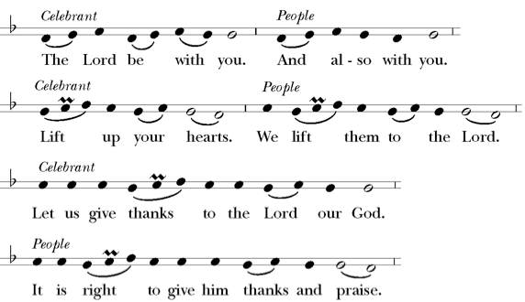
Then, facing the Holy Table, the Celebrant proceeds
It is right, and a good and joyful thing, always and everywhere to give thanks to you, Father Almighty, Creator of heaven and earth. For in the multitude of your saints you have surrounded us with a great cloud of witnesses, that we might rejoice in their fellowship, and run with endurance the race that is set before us; and, together with them, receive the crown of glory that never fades away. Therefore we praise you, joining our voices with Angels and Archangels and with all the company of heaven, who for ever sing this hymn to proclaim the glory of your Name:
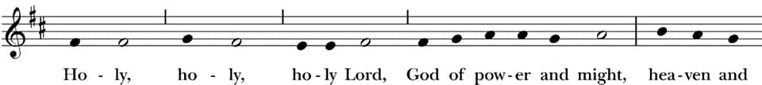
The Sanctus and Benedictus

Holy, holy, holy Lord | The Hymnal 1982 S-124

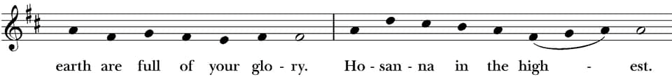
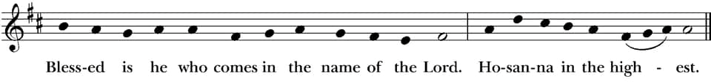

The people stand or kneel.
Then the Celebrant continues
Holy and gracious Father: In your infinite love you made us for yourself, and, when we had fallen into sin and become subject to evil and death, you, in your mercy, sent Jesus Christ, your only and eternal Son, to share our human nature, to live and die as one of us, to reconcile us to you, the God and Father of all.

He stretched out his arms upon the cross, and offered himself, in obedience to your will, a perfect sacrifice for the whole world.

On the night he was handed over to suffering and death, our Lord Jesus Christ took bread; and when he had given thanks to you, he broke it, and gave it to his disciples, and said, “Take, eat: This is my Body, which is given for you. Do this for the remembrance of me.”+

After supper he took the cup of wine; and when he had given thanks, he gave it to them, and said, “Drink this, all of you: This is my Blood of the new Covenant, which is shed for you and for many for the forgiveness of sins. Whenever you drink it, do this for the remembrance of me.”+

Therefore we proclaim the mystery of faith:
Celebrant and People
Christ has died.
Christ is risen.
Christ will come again.

The Celebrant continues
We celebrate the memorial of our redemption, O Father, in this sacrifice of praise and thanksgiving. Recalling his death, resurrection, and ascension, we offer you these gifts.

Sanctify them by your Holy Spirit to be for your people the Body and Blood of your Son, the holy food and drink of new and unending life in him. +Sanctify us also that we may faithfully receive this holy Sacrament, and serve you in unity, constancy, and peace; and at the last day bring us with all your saints into the joy of your eternal kingdom.

All this we ask through your Son Jesus Christ: By him, and with him, and in him, in the unity of the Holy Spirit all honor and glory is yours, Almighty Father, now and for ever. AMEN+

And now, as our Savior
Christ has taught us,
we are bold to say,

The Lord’s Prayer BCP 364
Our Father, who art in heaven,
hallowed be thy Name,
thy kingdom come,
thy will be done,
on earth as it is in heaven.
Give us this day our daily bread.
And forgive us our trespasses,
as we forgive those
who trespass against us.
And lead us not into temptation,
but deliver us from evil.
For thine is the kingdom,
and the power, and the glory,
for ever and ever. Amen.

Fraction BCP 364
The Celebrant breaks the consecrated Bread+. A period of silence is kept. Then may be sung or said
Alleluia. Christ our Passover is sacrificed for us;
People Therefore let us keep the feast. Alleluia

Facing the people, the Celebrant says the following Invitation
The Gifts of God for the People of God. Take them in remembrance that Christ died for you, and feed on him in your hearts by faith, with thanksgiving.
Hymns at Communion O thou who camest from above The Hymnal 1982#704 King of glory, King of peace The Hymnal 1982 #382
Lord, enthroned in heavenly splendor The Hymnal 1982 #307

We believe in the Real Presence of Christ in the Blessed Sacrament, the consecrated bread and wine. Communion in the Episcopal Church is open to all baptized
Christians and they are invited at this time to the altar rail to receive Christ’s Body and Blood. If you require a gluten-free wafer, please inform the Priest and one will be provided for you. Please let an usher know if you need Communion brought to your seat for any reason. If you wish to receive a blessing, please come forward and cross
your arms over your chest to signify that to the Priest. Prayers are offered in the Baptistry Chapel at the back of the church.

Post Communion Prayer BCP 366
After Communion, the Celebrant says
Let us pray.

Celebrant and People
Almighty and everliving God,
we thank you for feeding us with the spiritual food
of the most precious Body and Blood
of your Son our Savior Jesus Christ;
and for assuring us in these holy mysteries
that we are living members of the Body of your Son,
and heirs of your eternal kingdom.
And now, Father, send us out
to do the work you have given us to do,
to love and serve you
as faithful witnesses of Christ our Lord.
To him, to you, and to the Holy Spirit,
be honor and glory, now and for ever. Amen.

Lay Eucharistic Visitors are sent forth by all, saying: We send you forth bearing these holy gifts, that those to whom you go may share with us one
bread and one cup, the communion of Christ’s body and blood.

Blessing
The priest blesses the people, saying
The peace of God, which passes all understanding, keep your hearts and minds in the knowledge and love of God, and of his Son Jesus Christ our Lord; and the blessing of God Almighty, the +Father, the Son, and the Holy Spirit, be among you, and remain with you always. Amen.

* Dismissal
Celebrant Go in peace, glorifying the LORD by your life.
People Thanks be to God.
* Recessional Hymn Ye watchers, and ye holy ones The Hymnal1982#618
Postlude




The Altar flowers are given to the glory
In loving memory of

Our mother, Mary Gilliam Clark

By

Nancy Carr Korman, Elizabeth Carr Stallworth and Eugena Joseph Carr



Announcements

11/05/2025 -Noon HE and Healing service in the chapel.

11/05/2025-Choir practice at 4:30pm. (Please note time change)

11/05/2025-Wednesday night Bible Study and dinner is canceled this week.
UTO Boxes are ready to be picked up, and they are due back on November 23rd. One hundred percent of these offerings go to support God’s mission in the world. Notice the good things that happen each day. Give thanks to God for your blessings. Make an offering for each blessing. Your blessings become blessings for others.
Our monthly Parish Breakfast is next Sunday, November 9th at 9:00am. Please come and bring a friend. The food is always great, and it is a good time for fellowship.
St. Tim’s Lunch Bunch will meet in the Common Room following the 10:30am service on November 16th They will be going to The Whole Truth for lunch.

The Vestry

Class of 2025: Ann Barnes, Melba Martin, Bob Putney, Melissa Rees
Class of 2026: Lee Stephenson, Parker Garrett, Linda Connor, Sammy Gilmore
Class of 2027: Brandon McLean, Ray Harris, Kathryn Harrison, Scott Thompson

Welcome to St. Timothy's Episcopal Church! We are a welcoming, inclusive, and affirming church guided by scripture, tradition, and reason. We invite you to experience a relationship with Jesus, empowered by the Holy Spirit, by participating in the liturgy, engaging with the scriptures, and abiding in this Christian community of faith. In baptism, we covenant with God and each other striving for justice and peace, seeking Christ in all persons, loving our neighbors as ourselves, and respecting the dignity of every human being. We believe God loves you, just as you are, and so do we! So, whoever you are and wherever you are in your spiritual journey, you will be welcomed, loved, and affirmed at St. Timothy's. Everybody needs a place. We invite you to make this place your church home.

